Relational Antonyms

🔹 What is Relational Antonyms
# Source: AI Source: Provided by: [Data Path: Persons Table -> ID Column: 1, Name_En Column: Motasem Essam] -> From: [Chatgpt (GPT-4-turbo)] on [7/30/2025]
Relational antonyms (also called converses) are word pairs that describe a reciprocal relationship. The existence of one implies the existence of the other; they depend on each other to have meaning.

🧠 Definition:
# Source: AI Source: Provided by: [Data Path: Persons Table -> ID Column: 1, Name_En Column: Motasem Essam] -> From: [Chatgpt (GPT-4-turbo)] on [7/30/2025]
Relational antonyms are pairs in which one word implies a relationship that is reversed when the other word is used.

📌 Key Characteristics:
# Source: AI Source: Provided by: [Data Path: Persons Table -> ID Column: 1, Name_En Column: Motasem Essam] -> From: [Chatgpt (GPT-4-turbo)] on [7/30/2025]
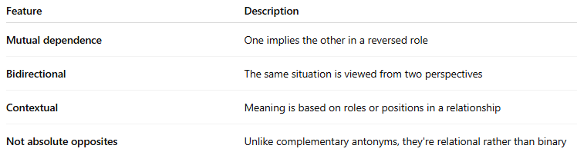
Feature | Description
Mutual dependence | One implies the other in a reversed role
Bidirectional | The same situation is viewed from two perspectives
Contextual | Meaning is based on roles or positions in a relationship
Not absolute opposites | Unlike complementary antonyms, they're relational rather than binary

📚 Examples of Relational Antonym Pairs:
# Source: AI Source: Provided by: [Data Path: Persons Table -> ID Column: 1, Name_En Column: Motasem Essam] -> From: [Chatgpt (GPT-4-turbo)] on [7/30/2025]
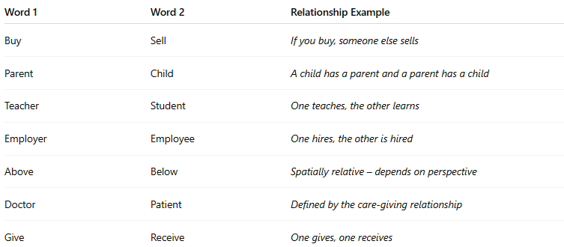
Word 1 | Word 2 | Relationship Example
Buy | Sell | If you buy, someone else sells
Parent | Child | A child has a parent and a parent has a child
Teacher | Student | One teaches, the other learns
Employer | Employee | One hires, the other is hired
Above | Below | Spatially relative – depends on perspective
Doctor | Patient | Defined by the care-giving relationship
Give | Receive | One gives, one receives

✏️ In Context:
# Source: AI Source: Provided by: [Data Path: Persons Table -> ID Column: 1, Name_En Column: Motasem Essam] -> From: [Chatgpt (GPT-4-turbo)] on [7/30/2025]
- If Sam is the employer, then John must be the employee.
- You can't sell something unless someone is there to buy it.

🔁 Comparison:
# Source: AI Source: Provided by: [Data Path: Persons Table -> ID Column: 1, Name_En Column: Motasem Essam] -> From: [Chatgpt (GPT-4-turbo)] on [7/30/2025]
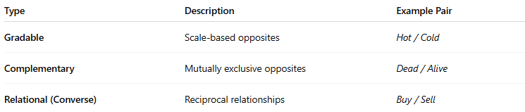
Type | Description | Example Pair
Gradable | Scale-based opposites | Hot / Cold
Complementary | Mutually exclusive opposites | Dead / Alive
Relational (Converse) | Reciprocal relationships | Buy / Sell

